Format of Question paper for Comprehensive Examination

Birla Institute of Technology & Science, Pilani
Work Integrated Learning Programmes Division
First Semester 2024-2025

Comprehensive Examination
(EC-3 Makeup)

Course No. : AIMLCL ZG513
Course Title : Advanced Deep Learning
Nature of Exam : Closed Book
Weightage : 40%
No. of Pages = 3

No. of Questions = 4
Duration :
Date of Exam :
Note to Students:
- Please follow all the Instructions to Candidates given on the cover page of the answer book.
- All parts of a question should be answered consecutively. Each answer should start from a fresh page.
- Assumptions made if any, should be stated clearly at the beginning of your answer.

Q.1. [6+2+2=10 Marks]

- Consider a standard DCGAN architecture which has a discriminator that takes as input 32x32x1 images and classifies these into real (1) and fake (0) images. The corresponding generator module takes as input an 80x1 normally distributed noise vector and uses the project and reshape function to convert the input vector to 4x4x128 followed by 3 transposed convolution layers (each with stride value 2). The first two transposed convolution layers have, respectively, 256 and 64 output channels. 3x3 filters are used in all transposed convolution layers. Generator conforms to the best practices of DCGAN construction. Calculate the total number of training parameters for the generator. Show all steps clearly to get partial marks.

# of output channels in 3rd transpose convolution layer = 1

# of convolution parameters = 9*(128x256+256x64+64x1) + (256+64+1) [including ReLU]
# of trainable batch normalization = 2*(256+64) [no batch normalization at output]
Total # of trainable parameters=

If a fully connected layer is used to implement the project and reshape function, number of trainable parameters in that layer = 80x4x4x128+4x4x128

- Why weight clipping is used in Wesserstein GAN?
To ensure bounded Lipshitz constant leading to stable training

- What is the purpose of spectral normalization in SN-GAN?
To ensure bounded Lipshitz constant

Q.2. 4+2+1+5=12 marks
- Match A, B, C and D with diffusion model, flow model, VAE and GAN.

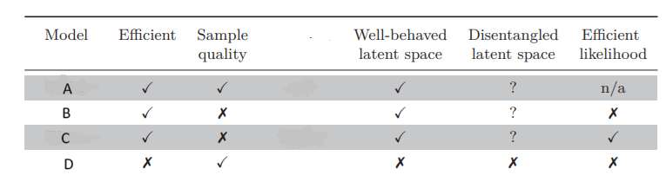

- What normalization is needed for a function f(x)= exp[-(x-4)²/16] to be used as the partition function in an energy-based generative model?
- Let μ_{data} = N(3,3) and μ_{g} = N(5,2) be the training data distribution and generated data distribution, respectively. What is the optimal discriminator function for a GAN?

- Assume a hypothetical generative model that has been trained with (0, 0), (0, 1), (1, 0) and (1, 1). (0, 0) and (0, 1) are in class 1, and (1, 0) and (1, 1) in class 2. The generated four data points are (0.9, 0.2), (0.2, 0.3), (0.7, 0.7), and (0.1,0.1). Calculate
- the Inception Score (IS) and
- Frechet Inception distance score (FID).
Clearly mention all your assumptions. Comment on the quality of the generated data based on these scores.

Q.3. TO BE RELEASED AFTER EVALUATION IS COMPLETE [4+4=8 Marks]

- In a variational autoencoder, after training the learnt latent space distribution is characterized by mean vector μ_{z} = [0 0] and covariance matrix

Σ_{z} = [2 0
0 3]
Assuming after training, p_{φ}(z|x) = p_{θ}(x|z), what is the variational loss value associated with this VAE. Show all steps clearly!

- Consider transforming a standard normal distribution in a flow model:
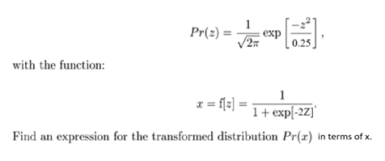
Q.4. [6+3+1=10 Marks]
A. Assume the following basic AE is used to calculate p(x₁), p(x₂|x₁), p(x₃|x₁, x₂) and p(x₄|x₁, x₂, x₃). x1 arrives first, x2 next and x4 at the end, as shown in the figure. All node numberings are specified.
i) Design all the necessary masks W¹, W² and V and show the final connections in the required MADE. Show all steps. W¹, W² are type-2 masks and V is of type-1.

ii) How many weights are associated with the output nodes numbered 1 and 3 in the output layer?
iii) What are the trainable parameters associated with output nodes numbered 1 and 3 in the output layer?
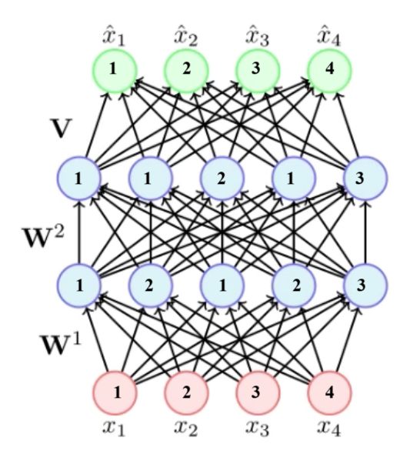
i)
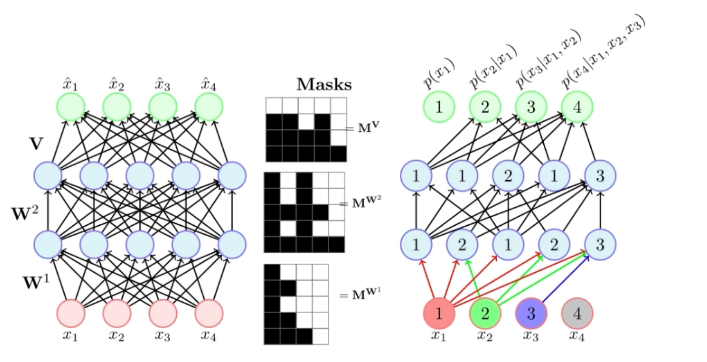
Black indicates 1 and white indicates 0.

- 0 trainable weight for output node numbered 1 and 4 trainable weights for node #3.
- 1 trainable parameter for node #1 and 5 trainable parameters for node #3.

